***FIRST* Tech Challenge**



**Team 15342 Aries**

2018-2019 Business Plan

[RHSAriesRobotics@gmail.com](mailto:RHSAriesRobotics@gmail.com)

<https://rhsariesrobotics.wixsite.com/website>

**TABLE OF CONTENTS**

**Page Number**

**1.0 Introduction**

1.1 *FIRST***®** Description **. . . . . . . . . . . . . . . . . . . . . . . . . . . . . . . . 3**

1.2 *FIRST***®** Tech Challenge Overview **. . . . . . . . . . . . . . . . . . . . . . . . 3**

**2.0 Executive Summary**

2.1 Team Purpose **. . . . . . . . . . . . . . . . . . . . . . . . . . . . . . . . . . . . 3**

2.2 Team Motto **. . . . . . . . . . . . . . . . . . . . . . . . . . . . . . . . . . . . . 4**

2.3 RHS Robotics Description **. . . . . . . . . . . . . . . . . . . . . . . . . . . . . 4**

2.4 Team Aries Members and Organizational Structure **. . . . . . . . . . . . . . . . 4**

2.5 Team Mascot **. . . . . . . . . . . . . . . . . . . . . . . . . . . . . . . . . . . . 5**

2.6 Mentorship and Coaches **. . . . . . . . . . . . . . . . . . . . . . . . . . . . . . 5**

2.7 Team Relationships and Sponsors **. . . . . . . . . . . . . . . . . . . . . . . . . 5**

**3.0 Sustainability**

3.1 Team Mission **. . . . . . . . . . . . . . . . . . . . . . . . . . . . . . . . . . . . 6**

3.2 Gender Equality **. . . . . . . . . . . . . . . . . . . . . . . . . . . . . . . . . . .7**

3.3SWOT Analysis**. . . . . . . . . . . . . . . . . . . . . . . . . . . . . . . . . . . 8**

3.4 Team Goals and Actions **. . . . . . . . . . . . . . . . . . . . . . . . . . . . . . 9**

3.5 Team Budgeting**. . . . . . . . . . . . . . . . . . . . . . . . . . . . . . . . . . .10**

**4.0 Outreach and Recognition**

4.1 Outreach**. . . . . . . . . . . . . . . . . . . . . . . . . . . . . . . . . . . . . . .11**

4.2 Team Photos **. . . . . . . . . . . . . . . . . . . . . . . . . . . . . . . . . . . . 13**

4.3 Robot Photos  **. . . . . . . . . . . . . . . . . . . . . . . . . . . . . . . . . . . .15**

**1.0 Introduction**

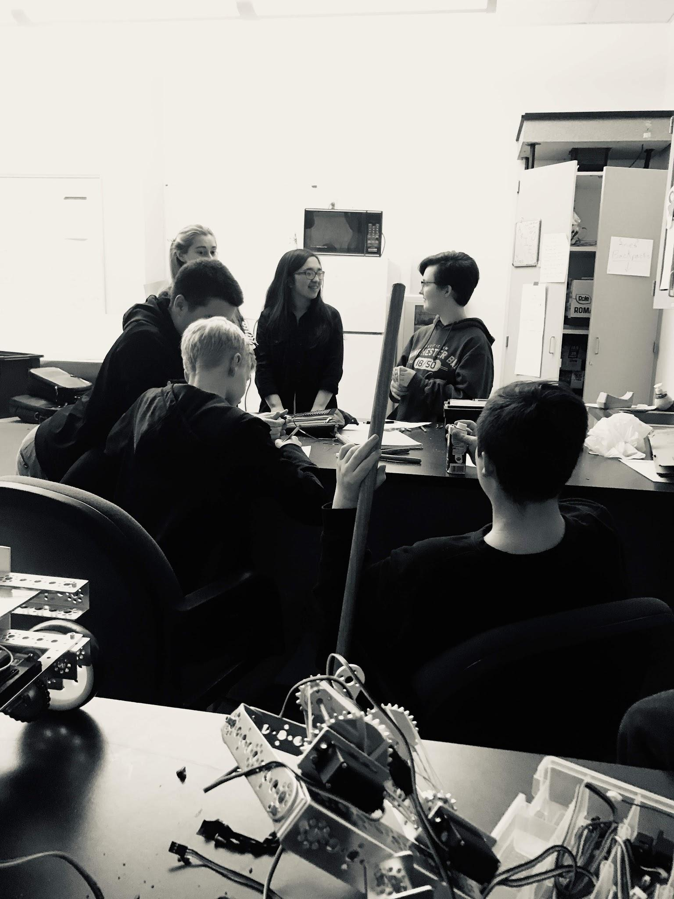

**1.1 *FIRST*® Description**

*FIRST***®** (For Inspiration and Recognition of Science and Technology) is an international foundation that promotes science and engineering through robotics. It was founded in 1989 by Dean Kamen and Woodie Flowers, both brilliant people. The mission of FIRST**®** is to “inspire young people to be science and technology leaders and innovators, by engaging them in exciting mentor-based programs that build science, engineering, and technology skills, that inspire innovation, and that foster well-rounded life capabilities including self-confidence, communication, and leadership.”

**1.2 *FIRST*® Description**

The *FIRST* Tech Challenge (FTC) is a robotics competition that provides students the opportunity to participate in a real world competitive STEM (Science, Technology, Engineering, and Math) team. Guided by adult Coaches and Mentors, students develop STEM skills and practice engineering principles (like keeping an engineering notebook), while realizing the value of hard work, innovation, and sharing ideas. The robot kit is reusable from year-to-year and can be programmed using a variety of languages, including Java. Teams also must raise funds, design and market their team brand, and do community outreach for which they can win awards. Participants have access to tens of millions of dollars in college scholarships. Each season concludes with regional championship events and an exciting *FIRST* Championship.

**2.0 Executive Summary**

**2.1 Team Purpose**

The purpose of our team is to increase interest in technology in our town, and to be a place to help foster and grow STEM knowledge and skills across our high school population.

**2.2 Team Motto**

*“Nobody who ever gave his (or her) best regretted it.”*

* George Stanley Halas

**2.3 RHS Robotics Description**

RHS Robotics got its start back in 2016 when they started as a VEX team. The following year, we were able to get 2 FTC team and 2 VEX teams. This year is the first year that we were able to get all FTC teams for our school, which brought the birth of our team. The majority of our team has not been in FTC, with only two members in FTC previously, and three members in FLL (*FIRST* Lego League) previously. We share a communal work room, with a separation of work spaces among the four RHS teams and more than 50 RHS Robotics members. Our team leader, John Sajo, was on the original VEX team in 2016 and has been a part of RHS Robotics ever since.

**2.4 Team Aries Members and Organizational Structure**

Our Team Members are as follows:

*stands for group leader ** stands for team leader

(There is only one Logan and one Hannah, but they both have two roles)

**2.5 Team Mascot**

As you probably saw on the front page, we have a team mascot. His name is Aries. Our team mascot came about from Gillian, an engineer drawing everyone on our team as Kirby, but with horns as similar to Aries. Each member of our team has their own specific Kirby, but the one on the front page is the one that stands representative for our entire team.

**2.6 Mentorship and Coaches**

We are fortunate to have an amazing group of amazing leaders and mentors we would like to acknowledge.

**Coach**

*Ira Wier*

*Photo courtesy of Roseburg High School*



**Coach**

Lydia Knight

*Photo courtesy of Roseburg High School*

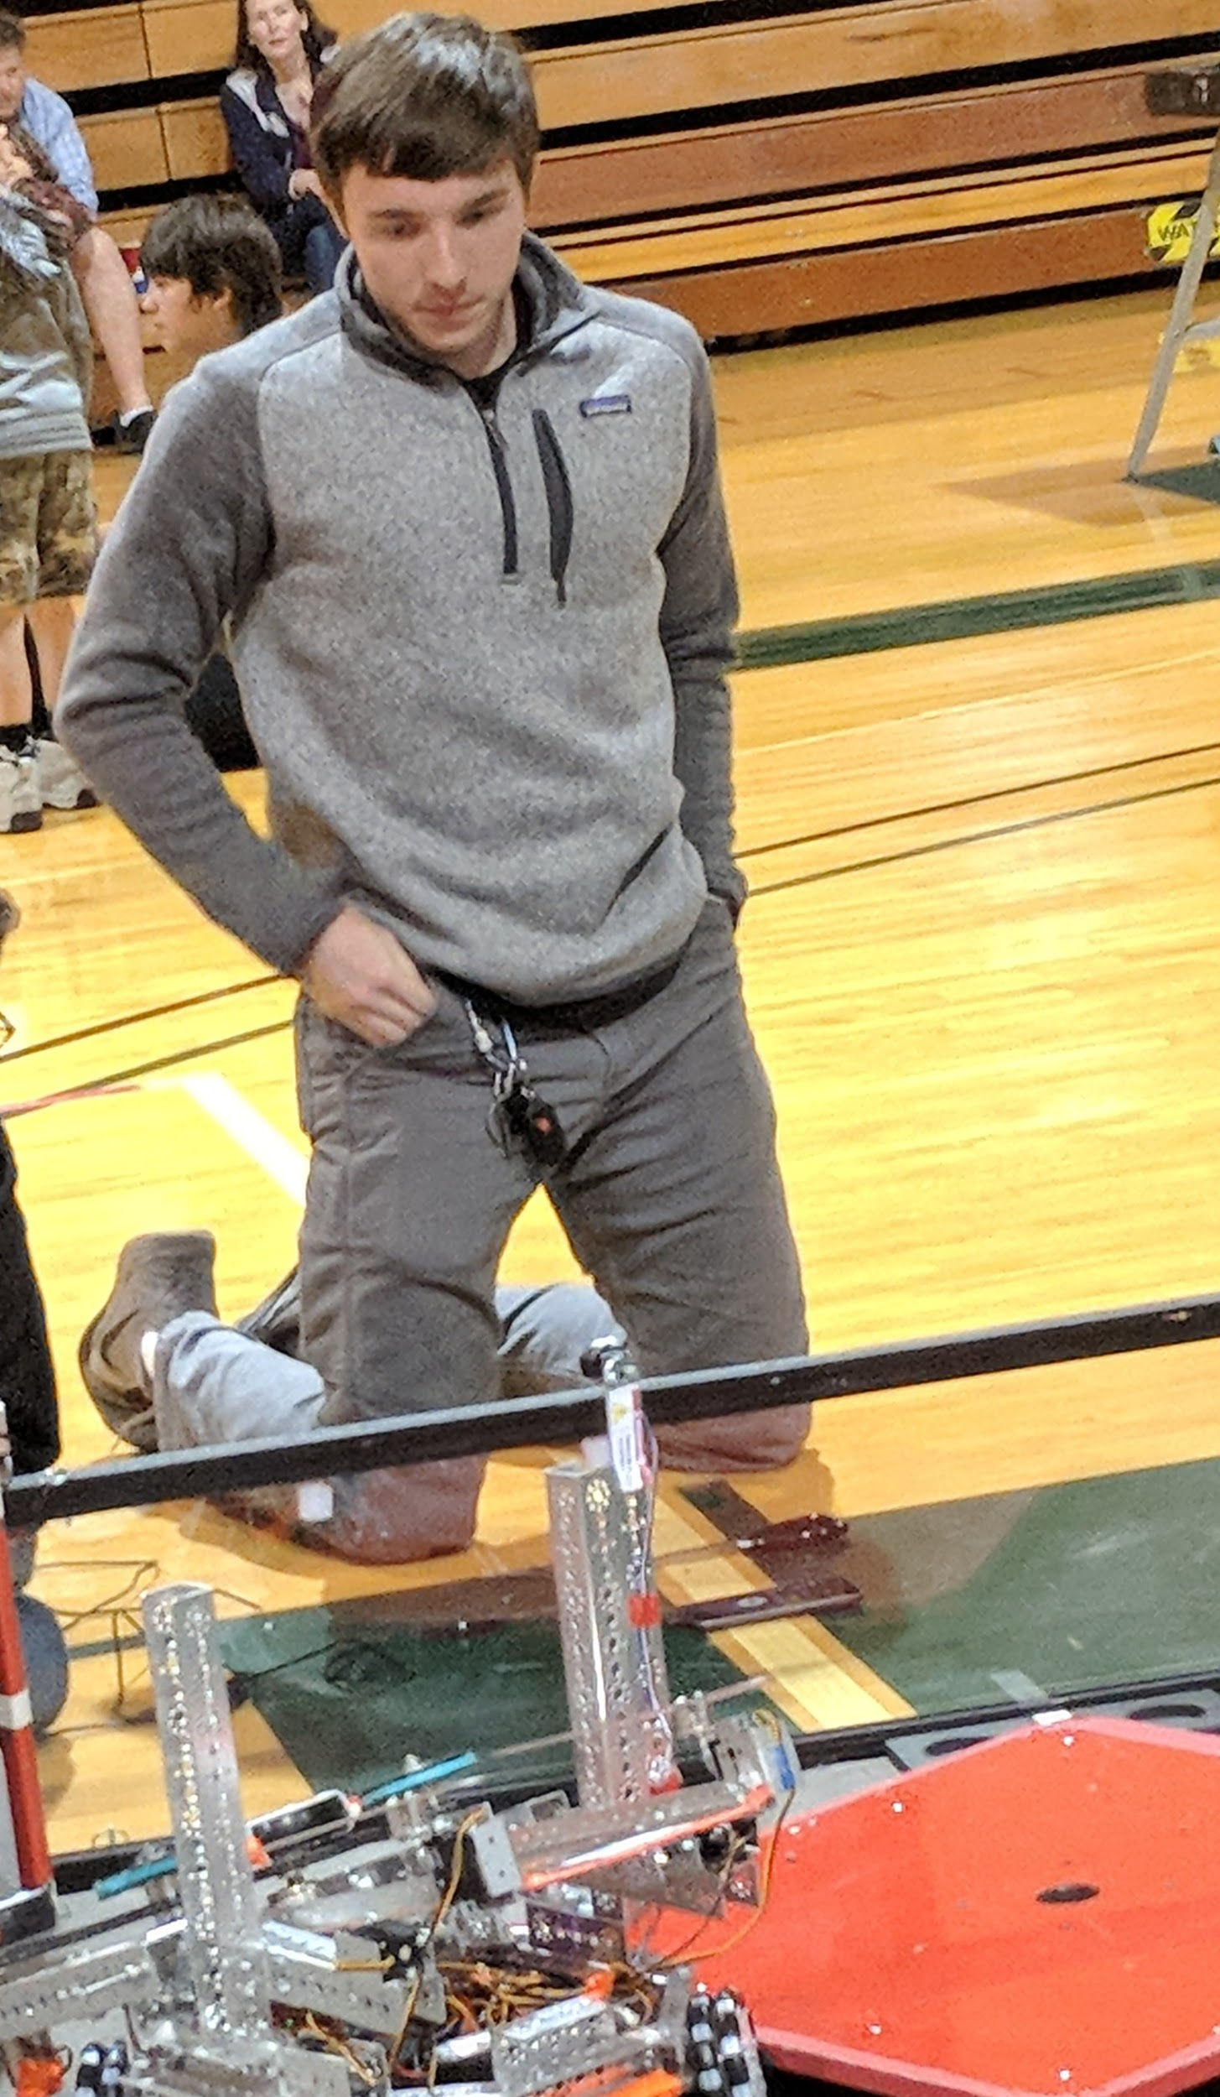

**Mentor**

Joe Davis

*RHS Robotics Alumni*

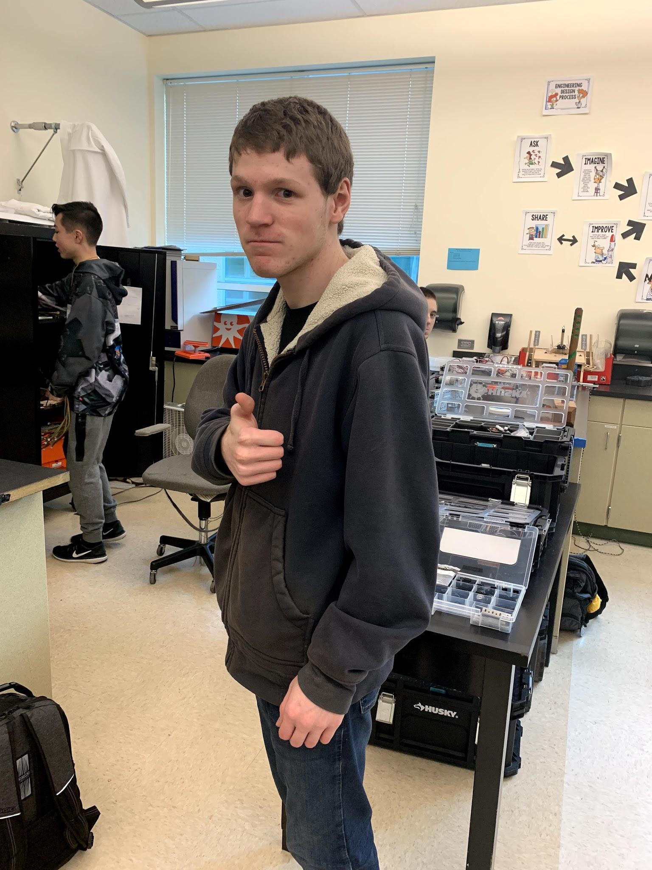

**Mentor**

Kohlton Kuczler

*Winning Alliance Captain at 2018 FTC Worlds*

**2.7 Team Relationships and Sponsors**

2017-2018 Sponsors:

Robotics Parent Organization (RPO)  *The RPO has been a constant support*

*for* RHS robotics. *They’ve helped with meets, sold concessions, and helped manage our program as a whole.*



*U- Haul has graciously provided us with financial backing this season, and we’d like to recognize them*

*for their support*



*Domino’s has graciously provided us with financial backing for our team and we’d like to recognize them for their support.*

*Performance Martial Arts Academy has graciously provided*

*us with financial backing this season and we’d like to*

*recognize them for their support.*



*Sherm’s Thunderbird Discount Market has graciously provided us with financial backing, and we’d like to recognize them for their support.*



*The Cow Creek Tribe of Umpqua Band of Indians has graciously provided us with financial backing this season, and we’d like to recognize them for their support.*

**3.0 Sustainability**

**3.1 2018 Mission Statement**

For the 2018/2019 season, Team Aries wants to spread *FIRST* and *FIRST* Tech Challenge throughout Southern Oregon by participating in community outreach and reaching out to local schools. For the Rover Ruckus competition, our goal is to be able to unlatch and hang, have a fully working autonomous program, and have a fully working intake system. We believe that we will be able to accomplish all of this by Meet 2 and 3. We plan to compete in local scrimmages, qualify for the Oregon State Championship, and hopefully qualify for the 2018 FTC World Championship.

**3.2 Gender Equality**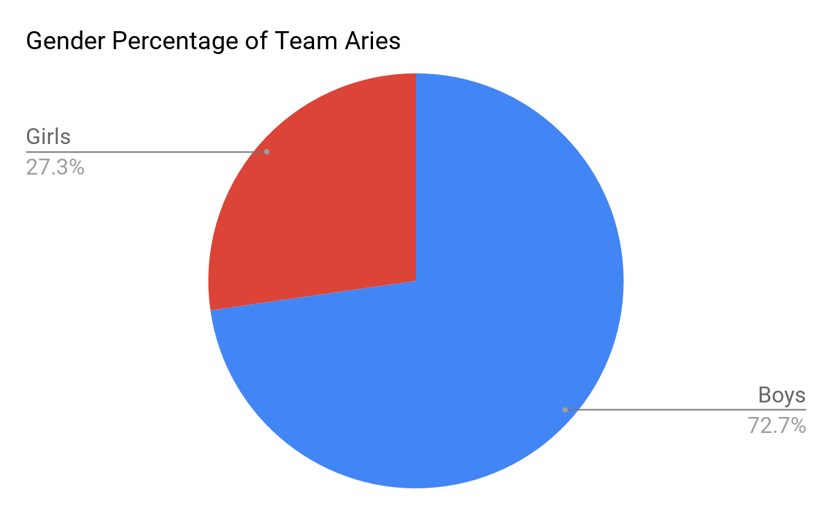

As you can see, Team Aries has an uneven gender ratio. We started off more even with our ratio being six girls and eight boys, but when three girls left our team to join Taurus we ended up with a very off-kilter situation. Girls went from making up about 43% of our team down to about 27% of our team. After Taurus, another team from RHS, was eliminated in Qualifiers we got one of the former members who had left to help out them this boosted the ratio to girls making up ⅓ of our team and boys making up the other 2/3 .

**3.3 SWOT Analysis**



To further explain:

Strengths: An advantage that contributes greatly to the strength of our team is that we’ve had the opportunity to host our earlier meets because we get more time to work on the robots and we are set up the way that works for us best. Our interactions with other teams comes from us sharing a room with three other teams and getting to see others grow separately and differently from our team.

Weaknesses: The inexperience weakness is that only a couple members on our team have done FTC before. Three others have been on FLL for the past two years. Most of us have some experience in our fields though, so that is a huge benefit. Another weakness is that the team regularly meets only three days a week.

Opportunities: We have been able to learn about past teams mistakes, which has been a guiding light for us when we were beginning to build our robot. Another opportunity that we have is that all of us have some form of experience in our group.

Threats: A lot of our teammates are involved in more than one activity, which means that robotics can conflict with their other activities. Another big threat is that communication for our team has not been as good as it can be. It has been improving, and I think it will be good by December.

**3.4 Team Goals and Actions**

|  |  |
| --- | --- |
| **ACTIONS** | **STRATEGY** |
| Expand the *FIRST* Program | * Start more FTC teams in Southern Oregon, especially in Roseburg * Spread awareness of FTC and STEM * Encourage other nearby schools to participate in FTC, promote local 4-H groups |
| Recruit new team members | * Attend outreach related to STEM and FIRST * Reach out to 4-H groups * Help out with middle school groups in an effort to get them to join our team next year. * Encourage friends and family to join |
| Develop Social Media Presence | * Connect with other FTC teams * Post regular updates * Create a YouTube channel so as to show the journey over the course of the season of our robot and team |
| Increase Team Funding | * Gain more team sponsors * Talk to local businesses about supporting our team * Plan fundraising events * Plan a spring dance/car wash |

**3.5 Team Budgeting**

|  |  |  |  |
| --- | --- | --- | --- |
| **Fundraising and Expenses** | | | |
| **Item #** | **Date** | **Explanation of Item/Fundraiser** | **Amount** |
| 1 | 9/10/2018- 1/11/2019 | Bottles and Cans Drive TOTAL | $466.05 |
| 2 | 7/30/2018 | RHS Foundation Grant Reimburse Robotic | $600.00 |
| 3 | 11/5/2018 | Concession Stand @ Tournament 0 | $545.00 |
| 4 | 11/17/2018 | Concession Stand @ Tournament 1 | $759.75 |
| 5 | 12/8/2018 | Concession Stand @ Tournament 2/3 | $800.00 |
| 6 | 1/19/2019 | Concession Stand @ SOAR Qualifiers | $872.25 |
| N/A | N/A | **TOTAL FUNDRAISED:** | **$4043.05** |
| 1 | 10/2/2018 | REV FIRST Tech Challenge Competition Set* | $396.39 |
| 2 | 10/2/2018 | FTC Team Registration* | $275.00 |
| 3 | 10/12/2018 | Organizing Bins, Rolling Systems, Tool Box** | $353.64 |
| 4 | 10/13/2018 | TETRIX MAX 4.7 mm Axle (Quantity: 4) | $63.80 |
| 5 | 10/13/2018 | TETRIX MAX Sprocket and Chain Pack (Quantity: 6) | $419.70 |
| 6 | 10/13/2018 | TETRIX MAX Continuous Rotation Servo (Quantity: 8) | $159.60 |
| 7 | 10/13/2018 | TETRIX MAX Worm Gear Box (Quantity: 4) | $139.80 |
| 8 | 10/13/2018 | TETRIX MAX Structure Pack (Quantity: 2) | $238.00 |
| 9 | 10/14/2018 | 0.770”-0.625” Pattern Adapter (Quantity Of Each: 32)  Clamping D-Hubs (Tapped), 0.770” Pattern | $345.87 |
| 10 | 10/14/2018 | REV Color Sensor V2 (Quantity: 6) | $84.00 |
| 11 | 10/19/2018 | Switch Cable and Bracket (Quantity: 8) | $48.00 |
| 12 | 11/3/2018 | REV JST PH 4-pin Sensor Cable - 4 pack (50 cm) (Quantity: 2) | $10.00 |
| 13 | 12/05/2018 | Linear Slider | $20.00 |
| 14 | 1/28/2019 | Linear Actuators (Quantity: 2) | $215.26 |
| **15 | 2/6/2019 | REV #25 Chain Tool (Quantity: 2) | $60.00 |
| 16 | 2/6/2019 | REV Logic Level Converter (Quantity: 32) | $96.00 |
| 17 | 2/6/2019 | REV Color Sensor V2 (Quantity: 2) | $28.00 |
| 18 | 2/6/2019 | REV Smart Robot Servo (Quantity: 3) | $90.00 |
| 19 | 2/6/2019 | REV Tamiya to XT30 Adapter - 2 Pack | $3.00 |
| 20 | 2/6/2019 | REV XT30 Extension Cable - 2 Pack Length: 50 cm (Quantity: 4) | $32.00 |
| 21 | 2/6/2019 | REV JST PH 3-pin Communication Cable - 2 Pack  Cable Length: 50 cm (Quantity: 4) | $12.00 |
| 22 | 2/6/2019 | REV M3 x 35cm Hex Cap Screws - 50 Pack | $8.00 |
| 23 | 2/6/2019 | REV 12V Slim Battery | $62.71 |
| N/A | N/A | **TOTAL EXPENSES:** | **$3160.77** |
| N/A | N/A | **RESERVES:** | **$882.28** |

*Applies to multiple teams **6 organizing bins, 3 rolling systems tool boxes, and 3 Tool Boxes 

Last updated February 8, 2019

Shipping expenses included in cost. In mass orders shipping is included along with final item

Fundraising/ Expenses is shared across all Roseburg High School teams

**4.0 Outreach and Recognition**

**4.1 Outreach**

For our outreach this year, we’ve had several opportunities to help out within our community and help spread the name of RHS Robotics and Team Aries. Some of our events that we have helped out with are: SOAR League Meet 0, SOAR League Meet 1, SOAR League Meet ⅔, Southern Oregon FLL Regional Meet, having build days with the Fremont Middle School team, participating and helping out with other clubs on campus (i.e. Conspiracy Theory Club, Astra, FCCLA, Interact, FBLA, Leadership, Hiking Club), communicating with people from Japan to help explain the mission of FIRST (Logan talked with people from Washinomiya Junior High School and Kurihashihigashi Junior High School, both in Kuki City, Saitama, Japan. He contacted a representative from both.), Operating a YouTube channel that has over 300 views as of January 31, 2019, Visiting Con-Vey Keystone to gain more knowledge about how they use robotics, working with the RHS business program, running booths at the 2018 Douglas County Fair, the 2018 UCC STEM fair, and the 2019 UCC Career Explore Night. We also came to the 2018 St. Mary’s Kickoff for the Rover Ruckus challenge. Some contact that we made with some STEAM professionals were having a video chat with Trevor Hixson, a engineer and programmer for Qualtrics, and contacting Nelson Scoville, an app designer and web programmer for Dell. The picture on the right is of Logan in Japan with the representative for Kurihashihigashi Junior High School, Hiroto Yamasaki. The picture below is of our YouTube channel and other outreach we have done.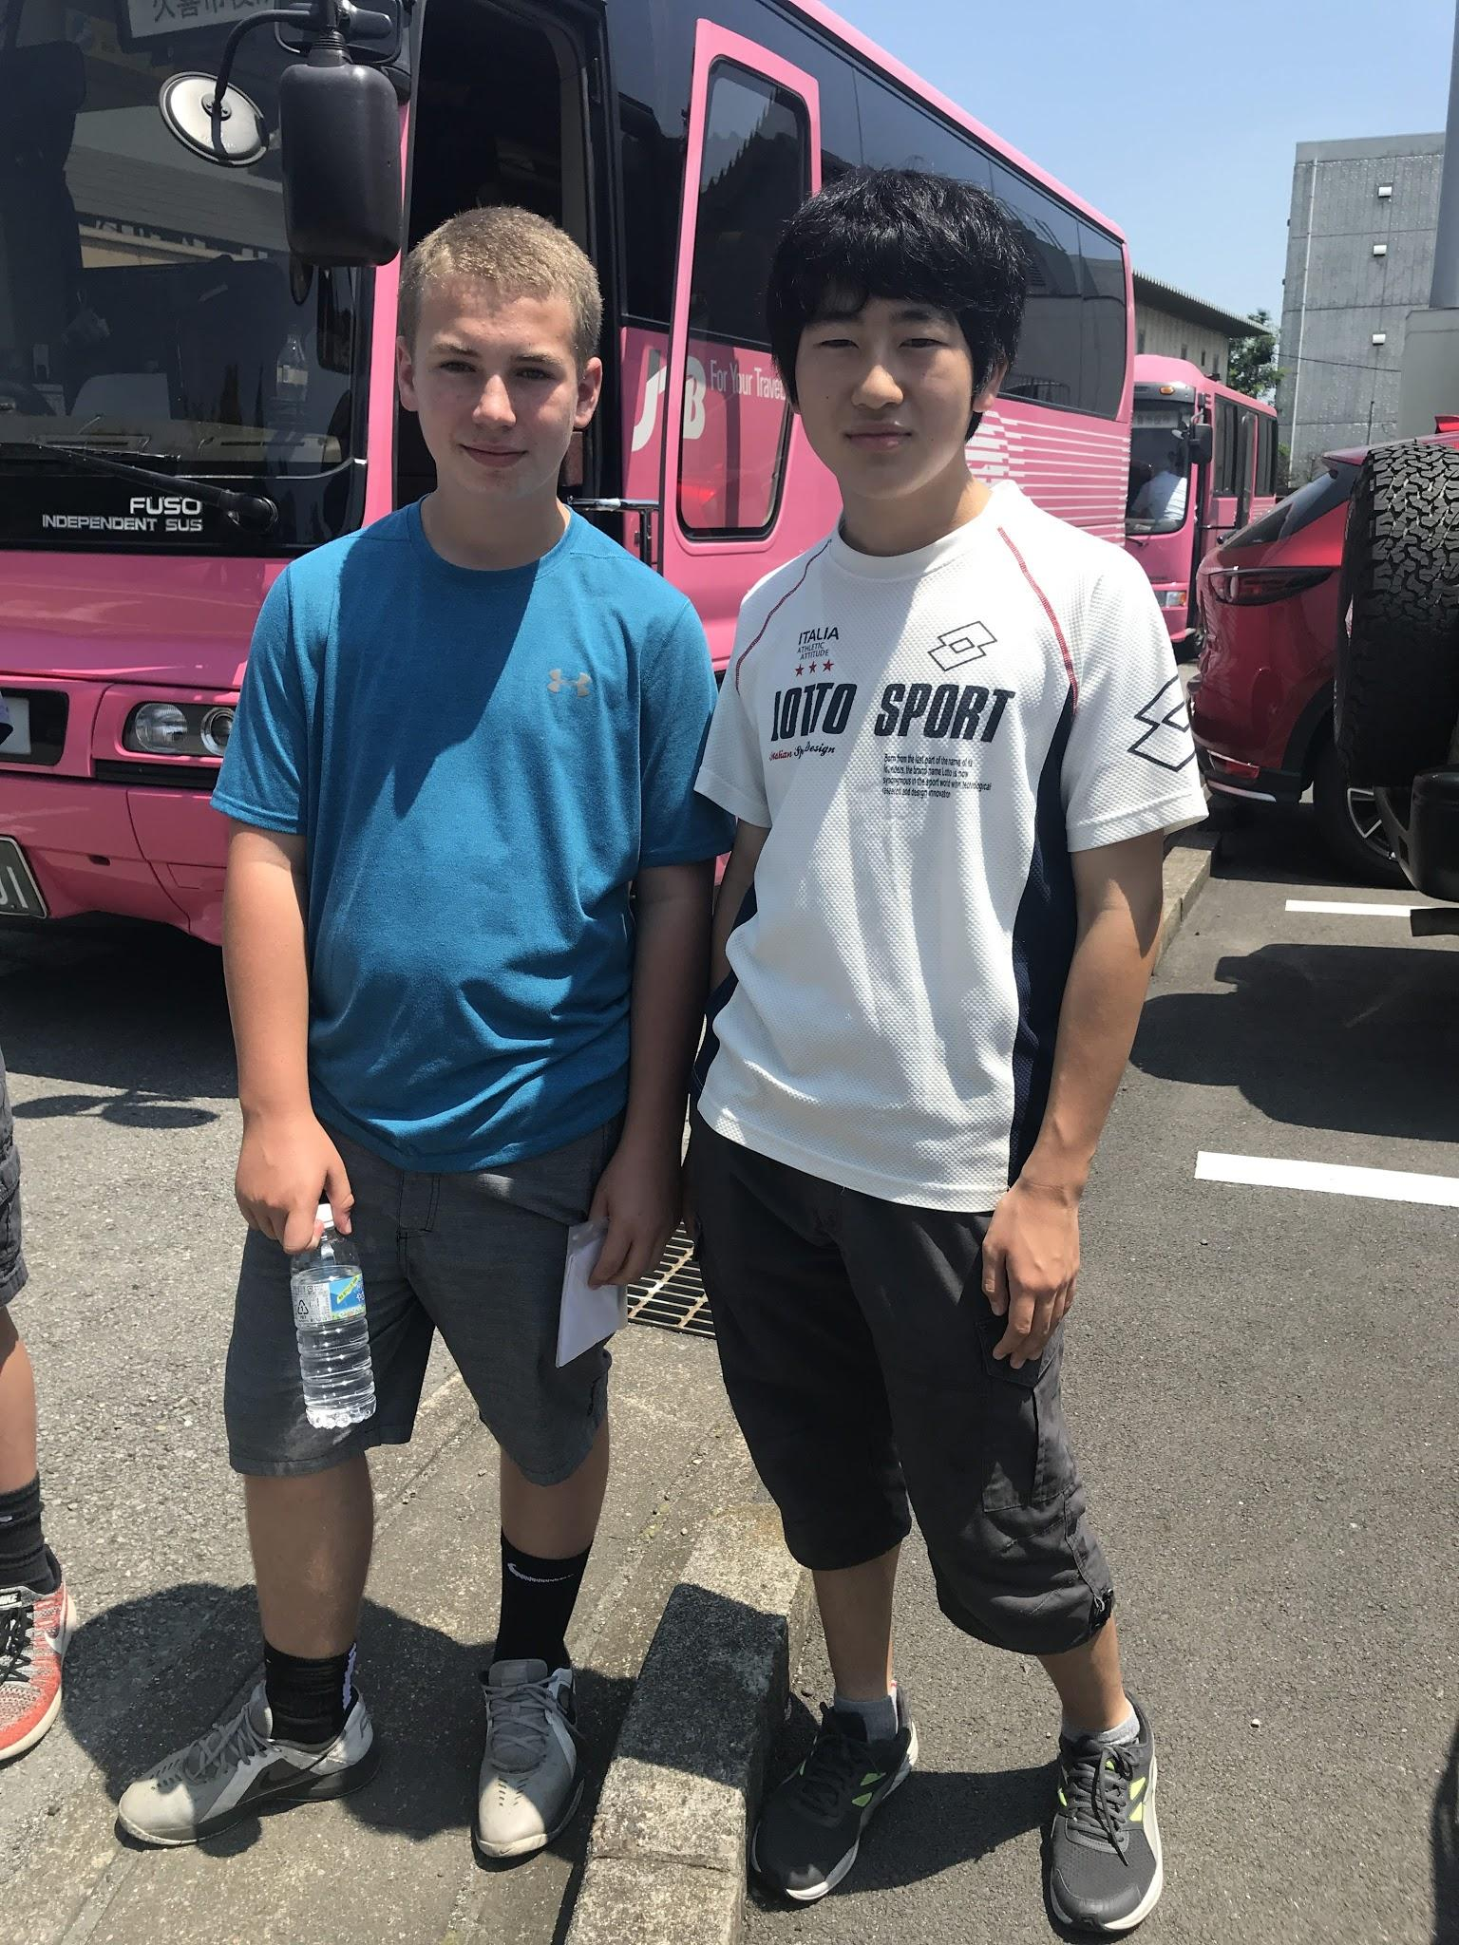

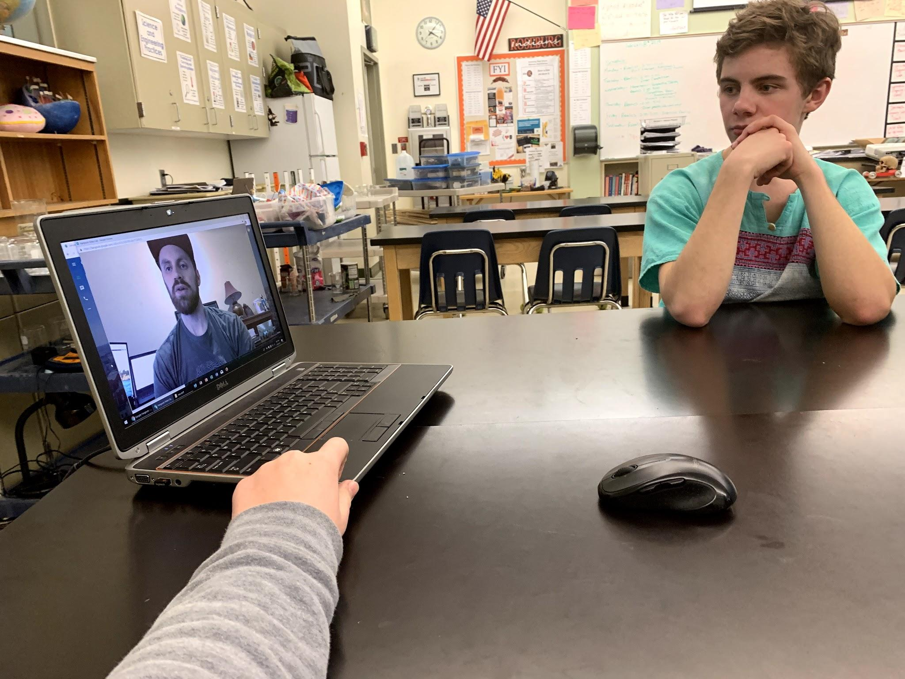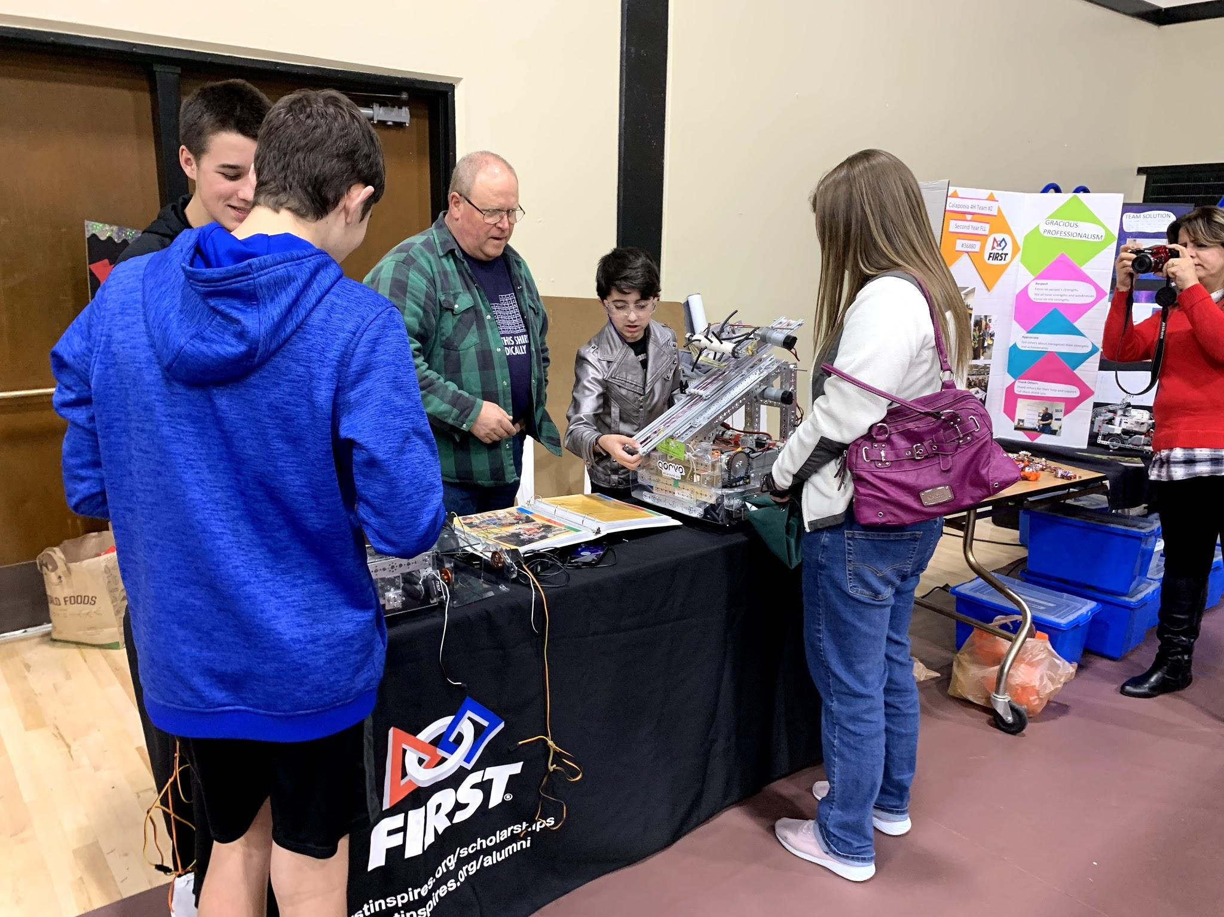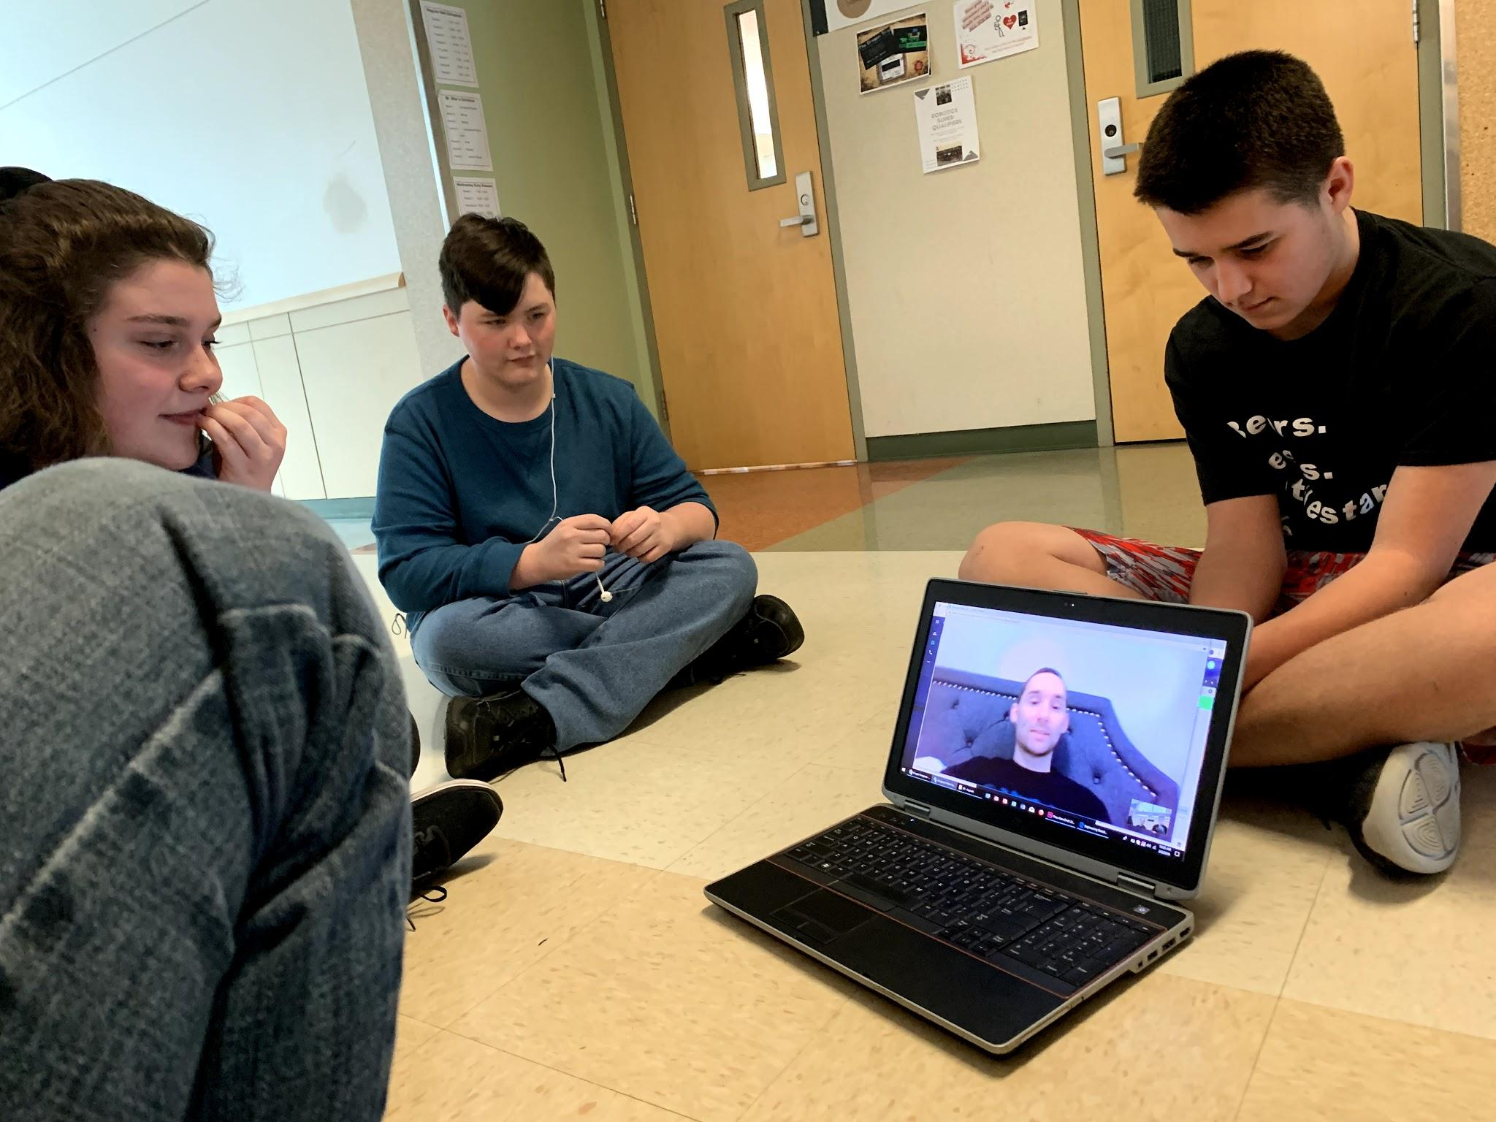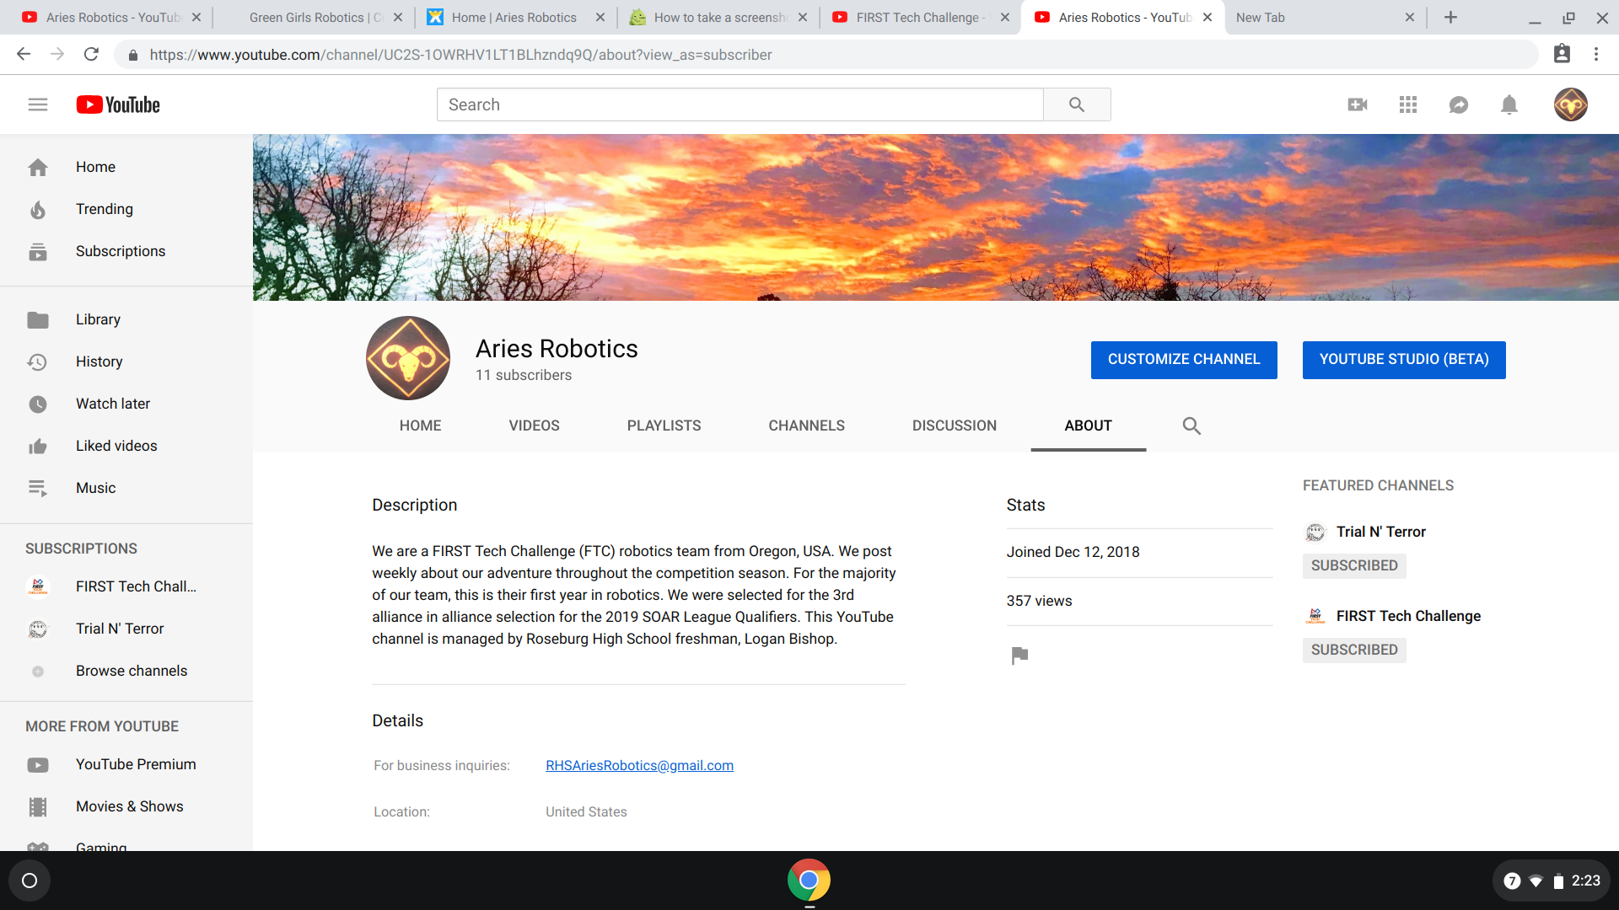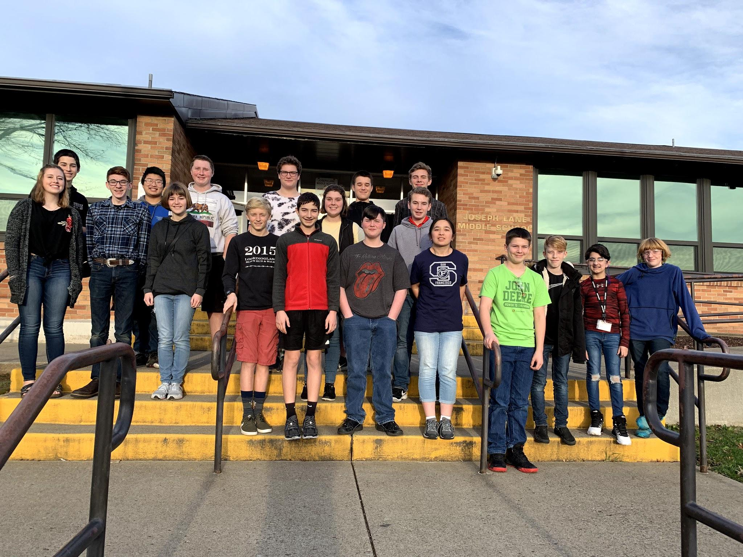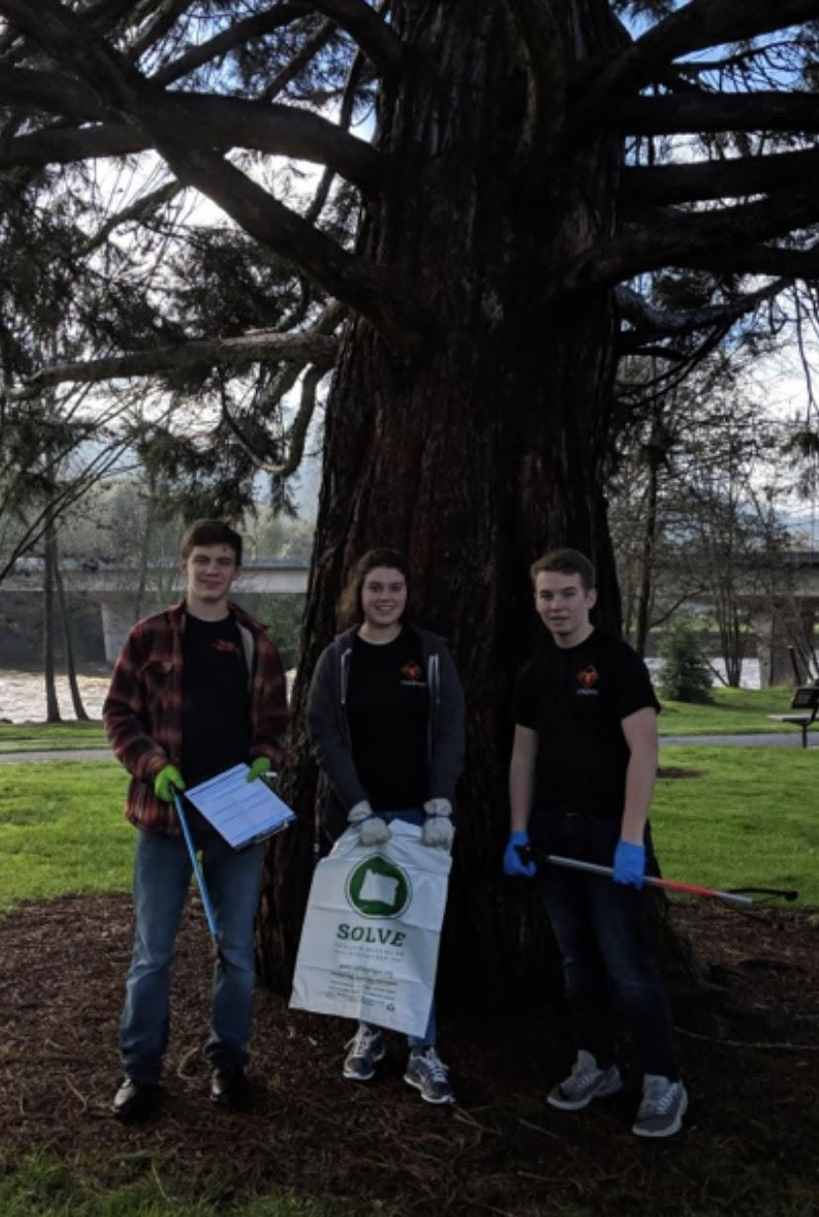

**4.2 Team Photos**

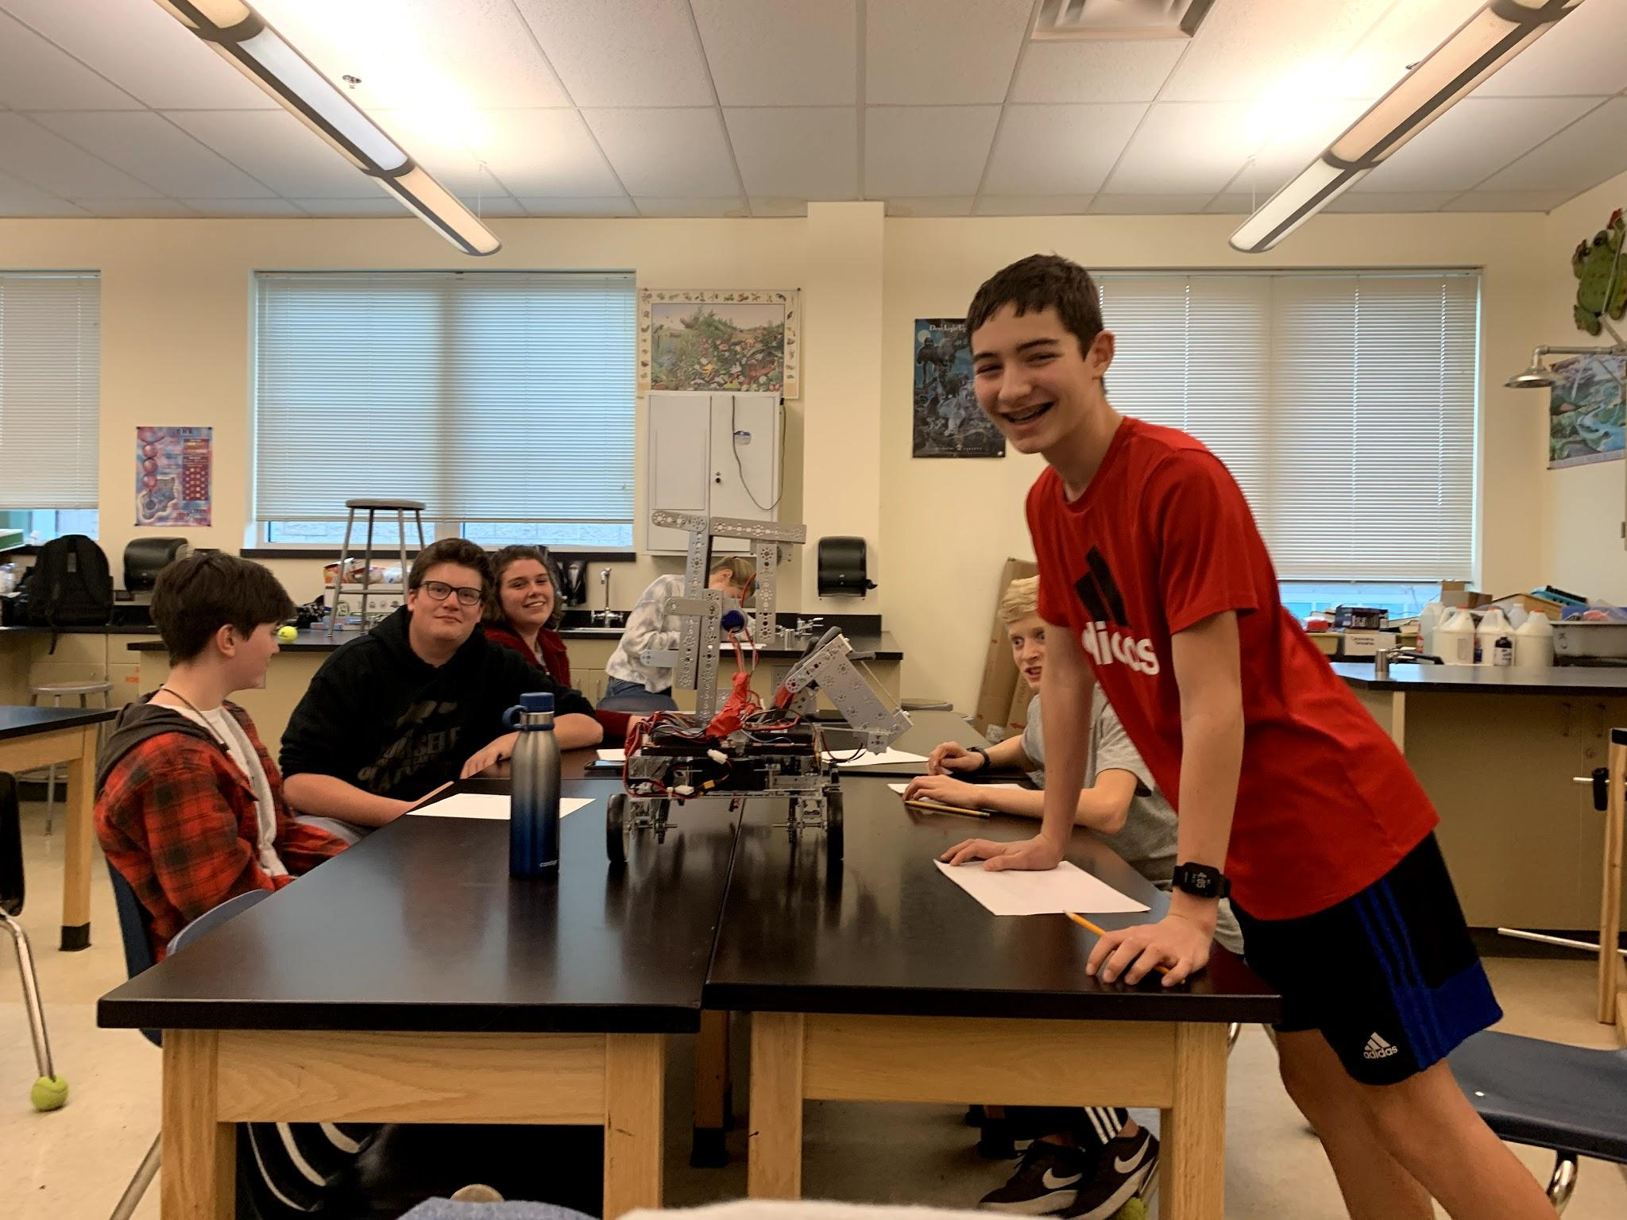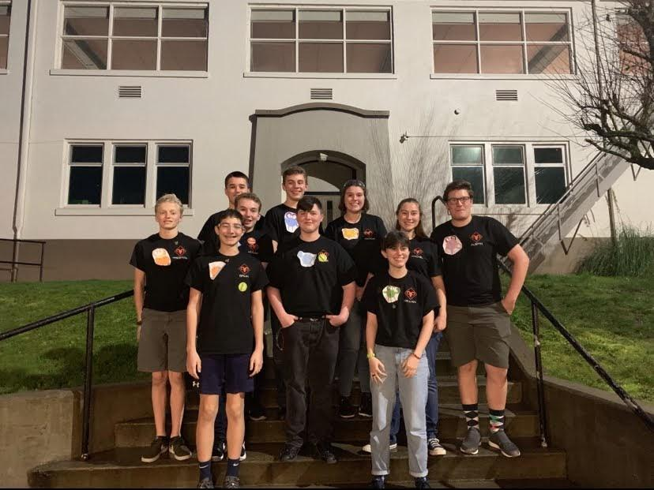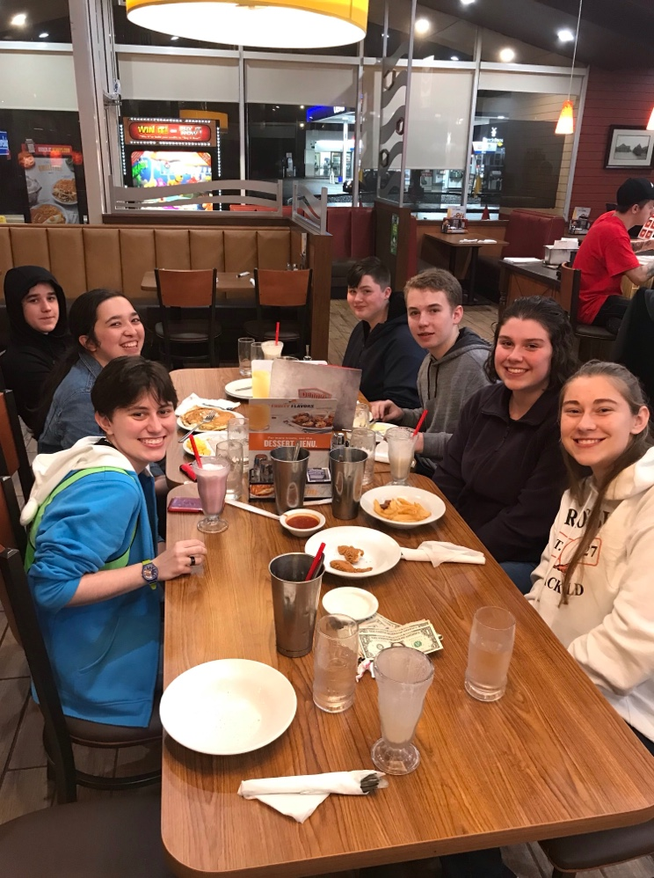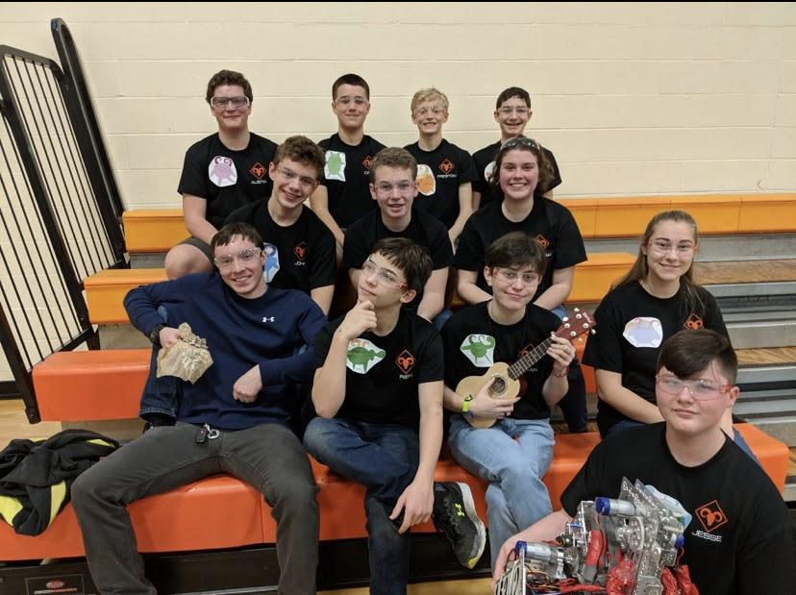

**More Team Photos**

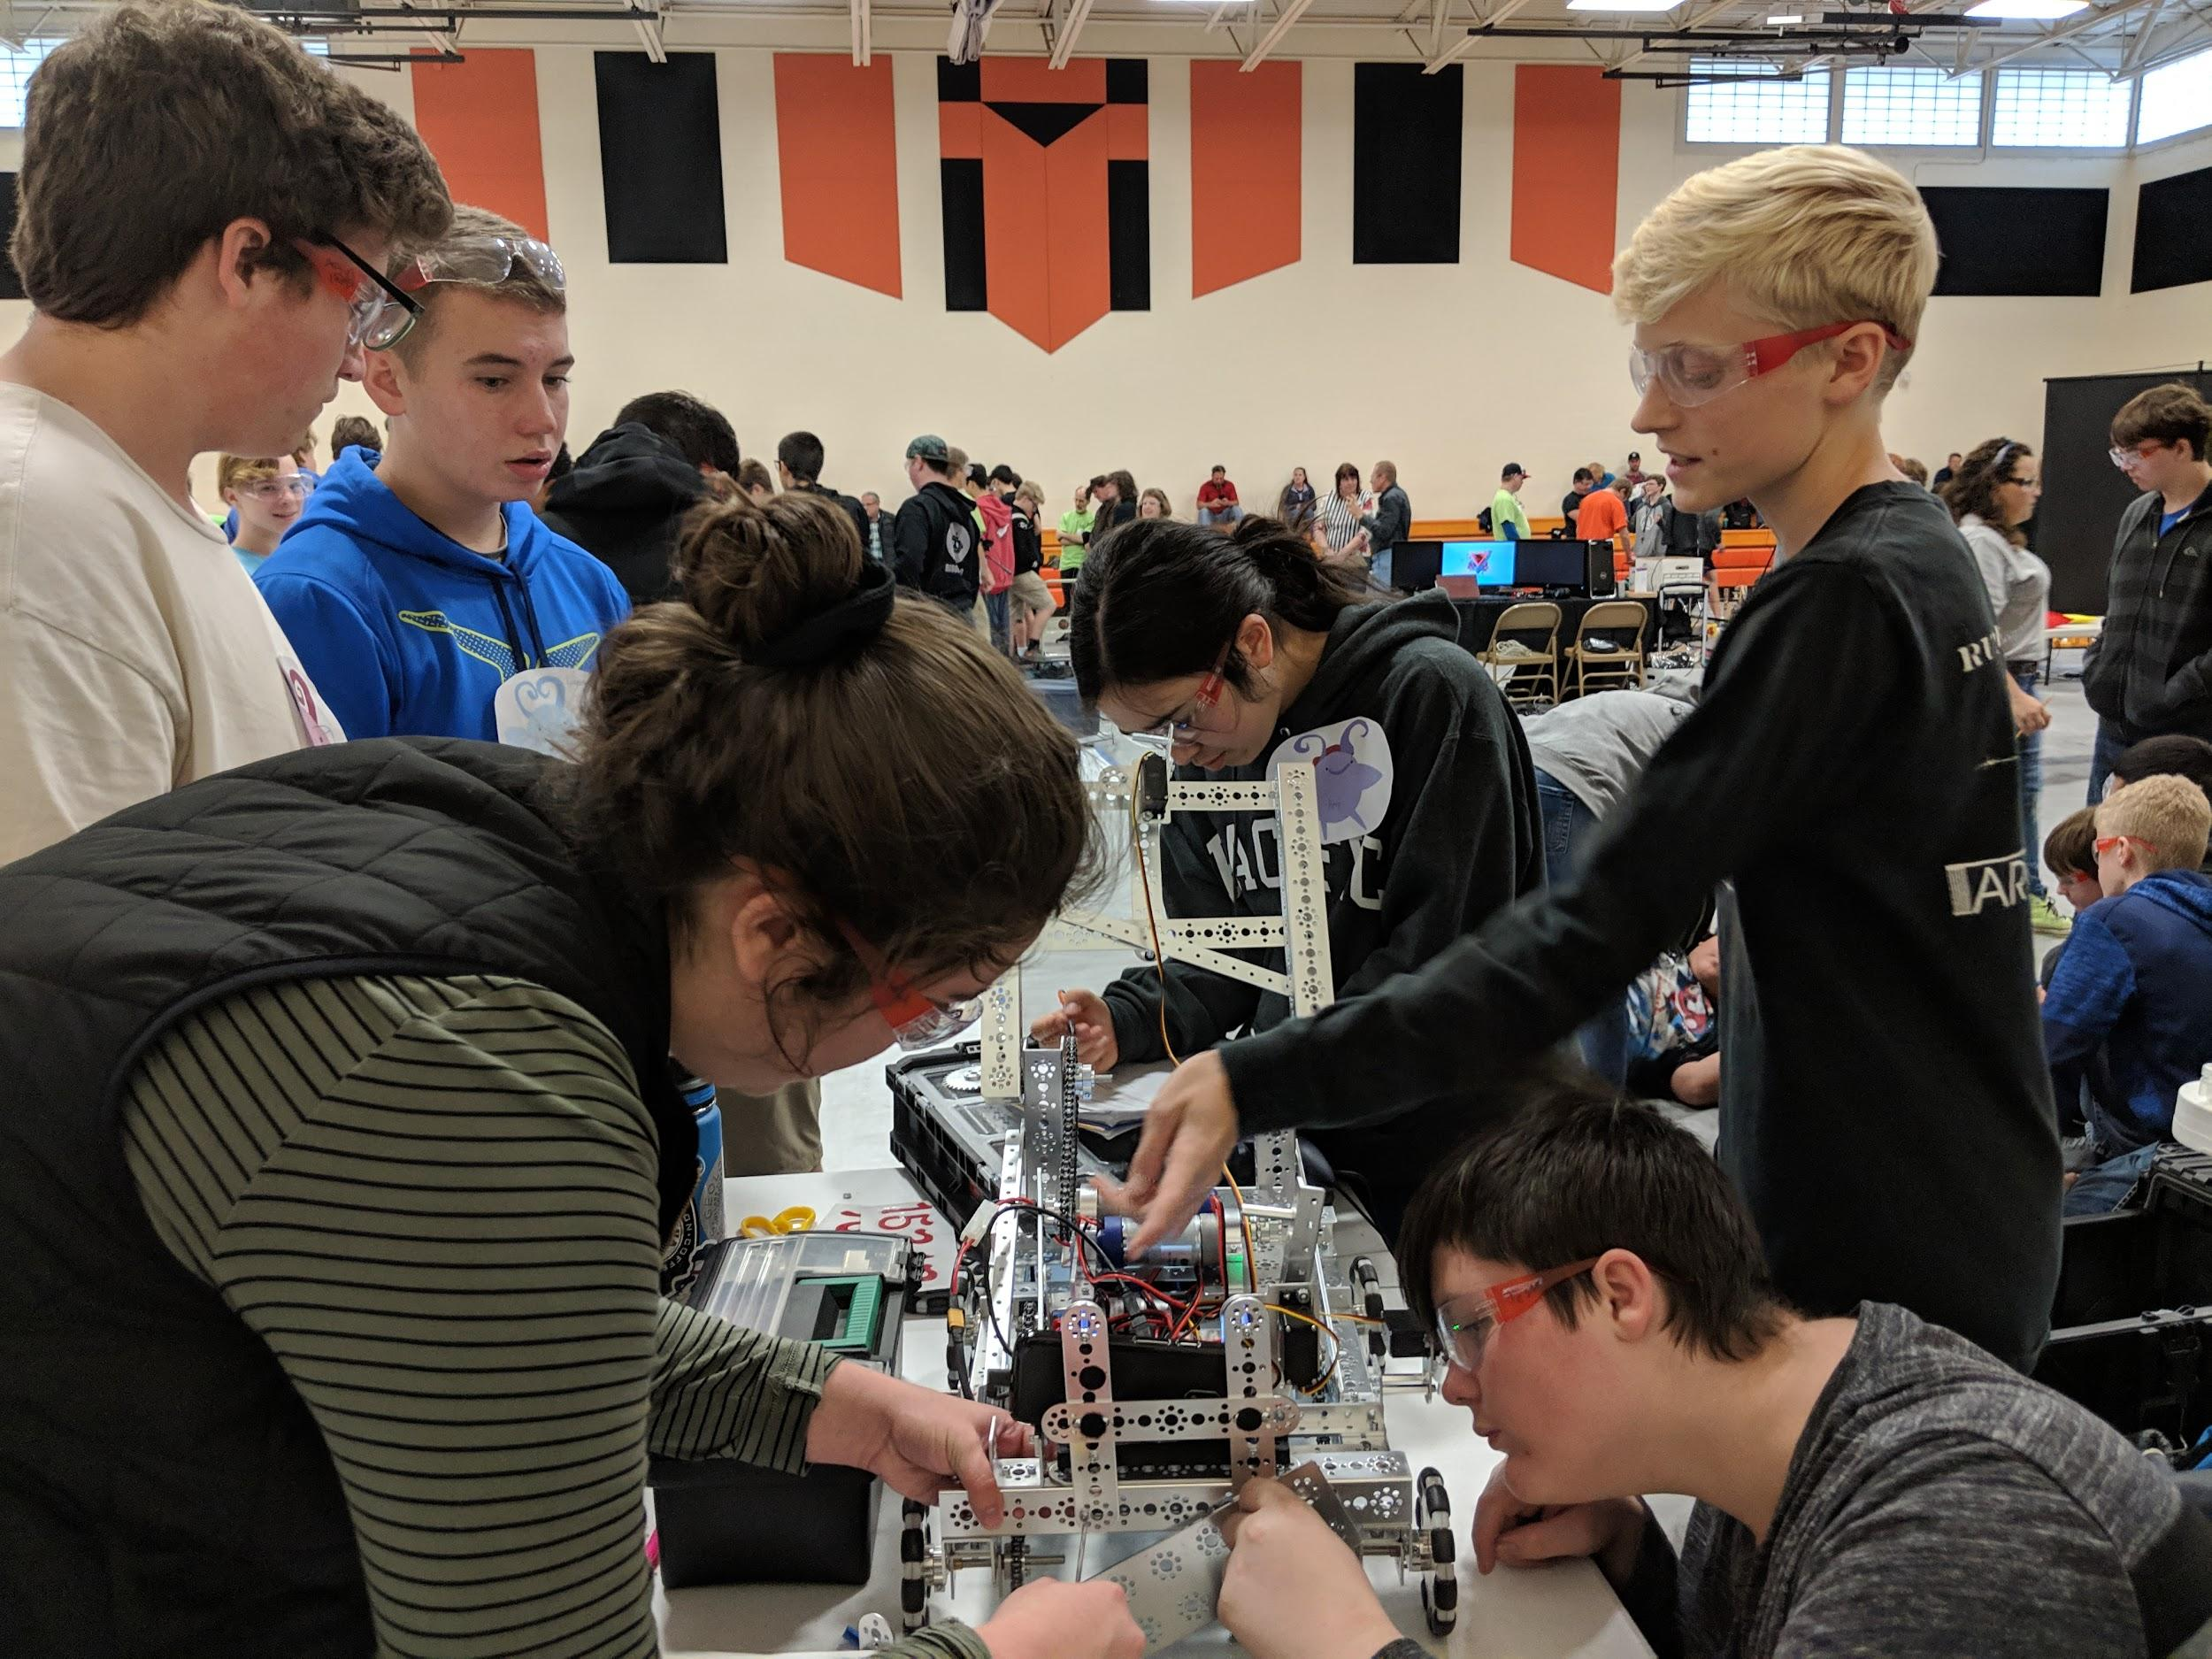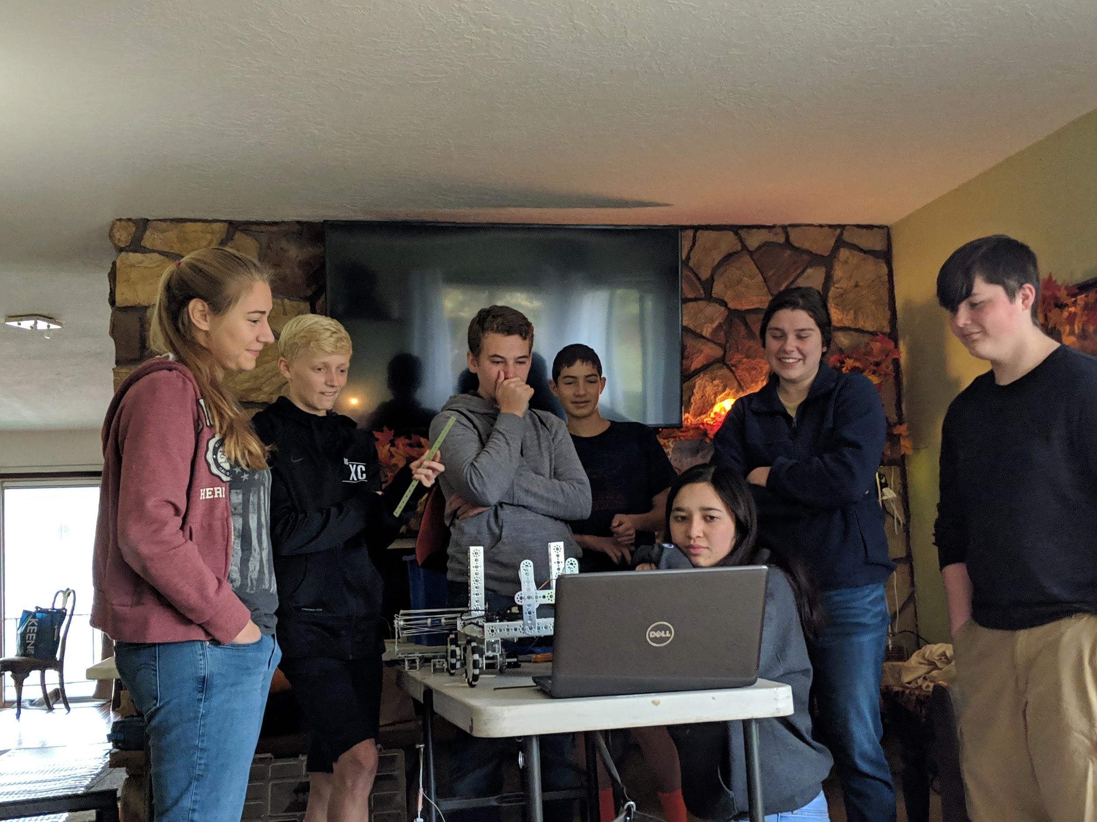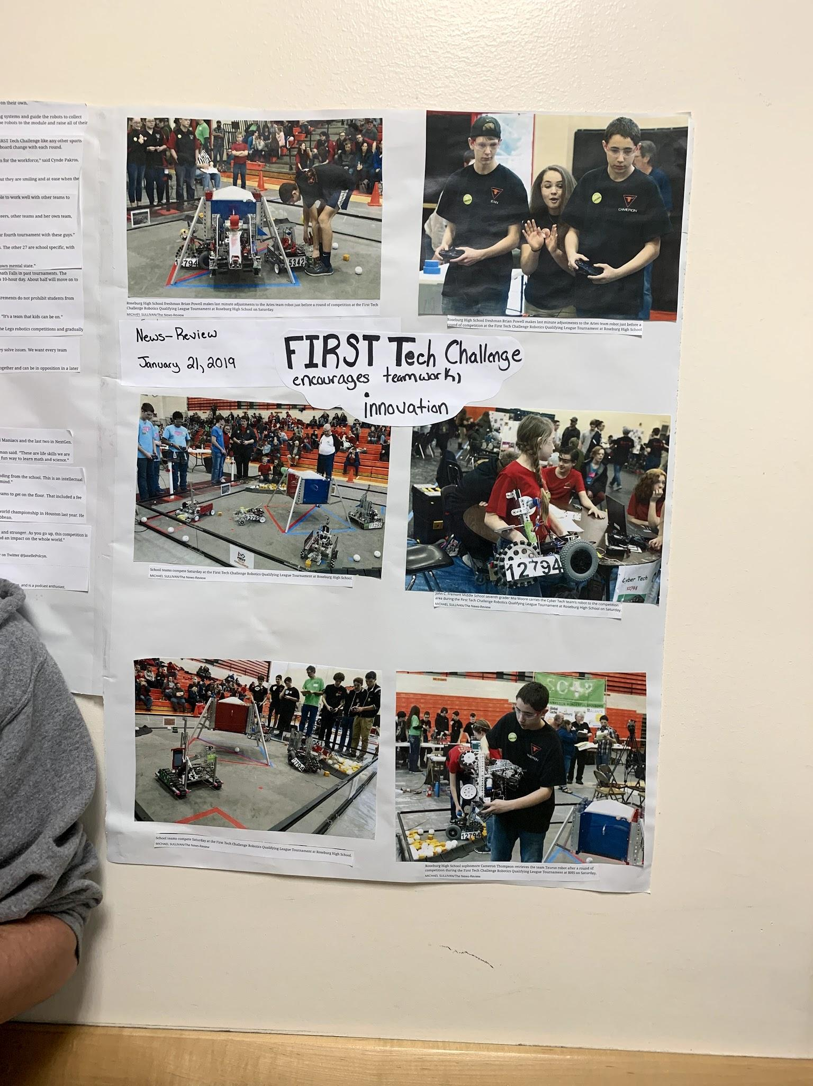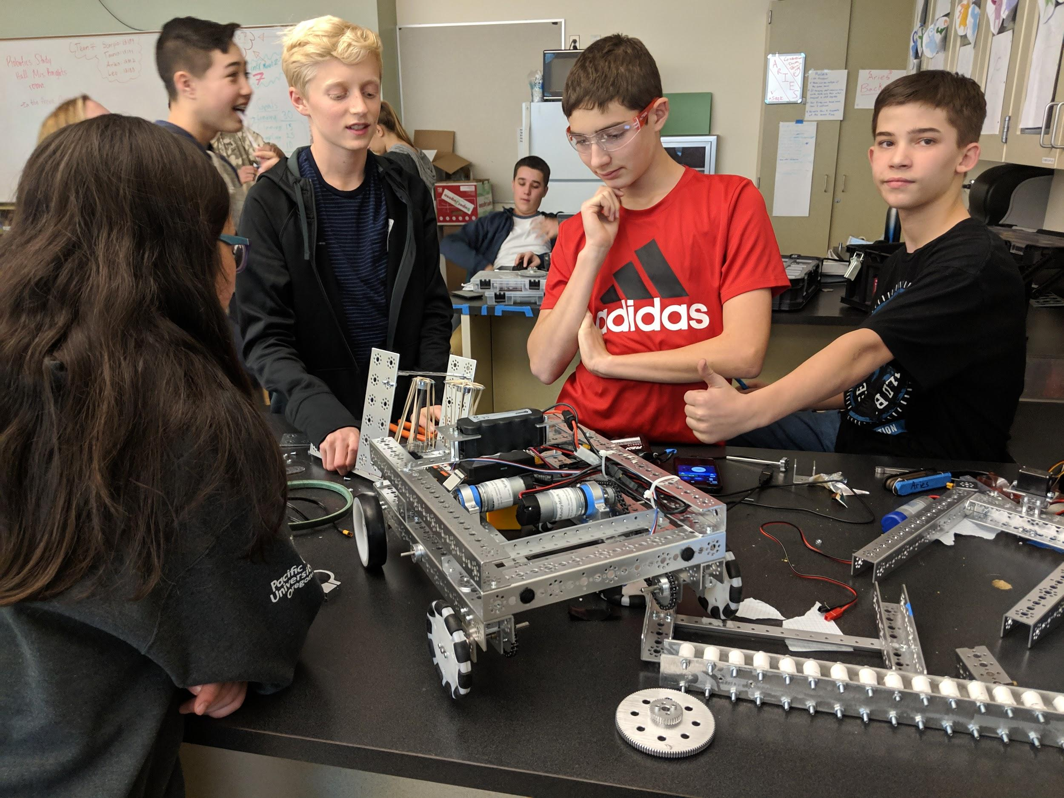

**4.3 Robot Photos**